CREATE TABLE “Branch”

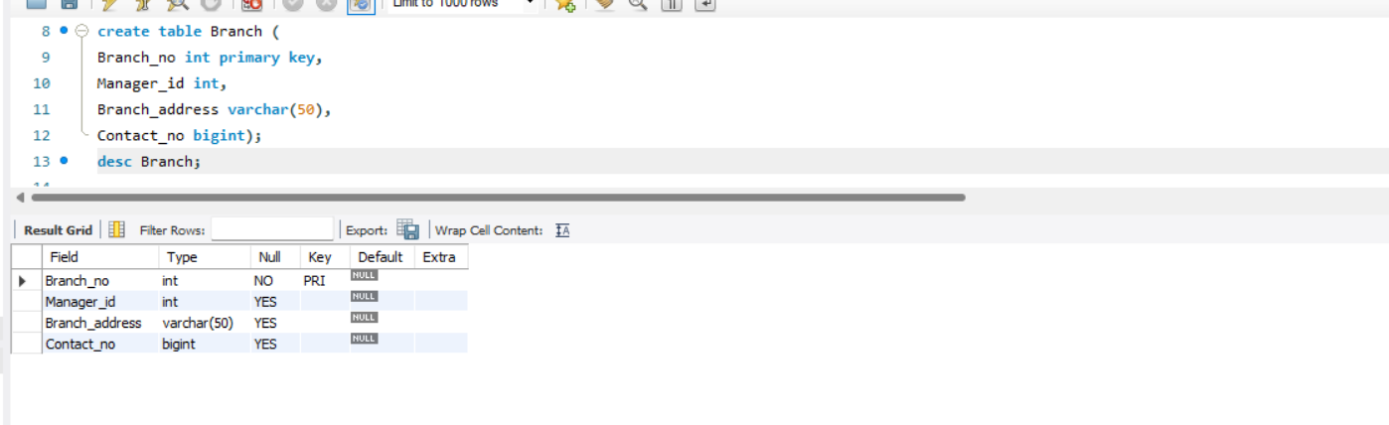

CREATE TABLE “Employee”

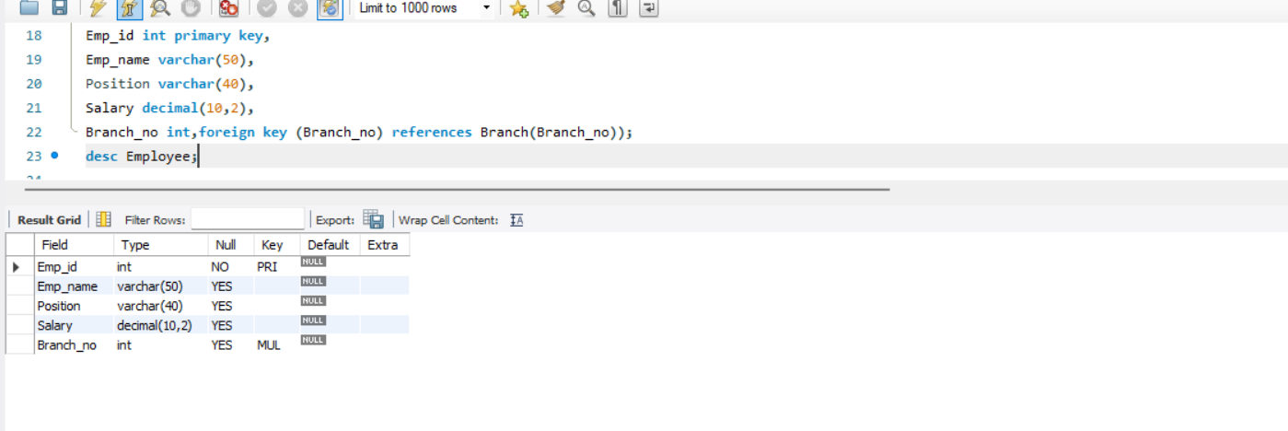

CREATE TABLE “Books”

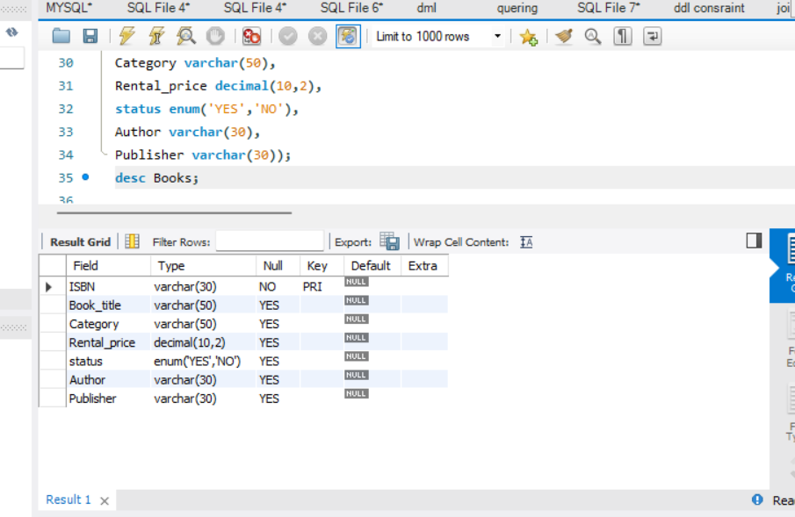

CREATE TABLE “Customer

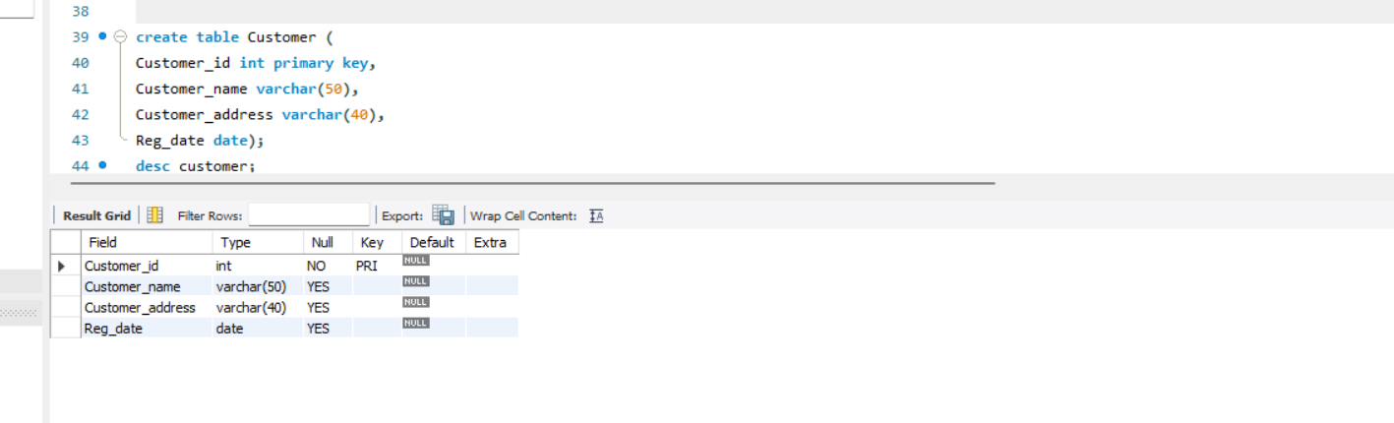

CREATE TABLE”Issuestatus”

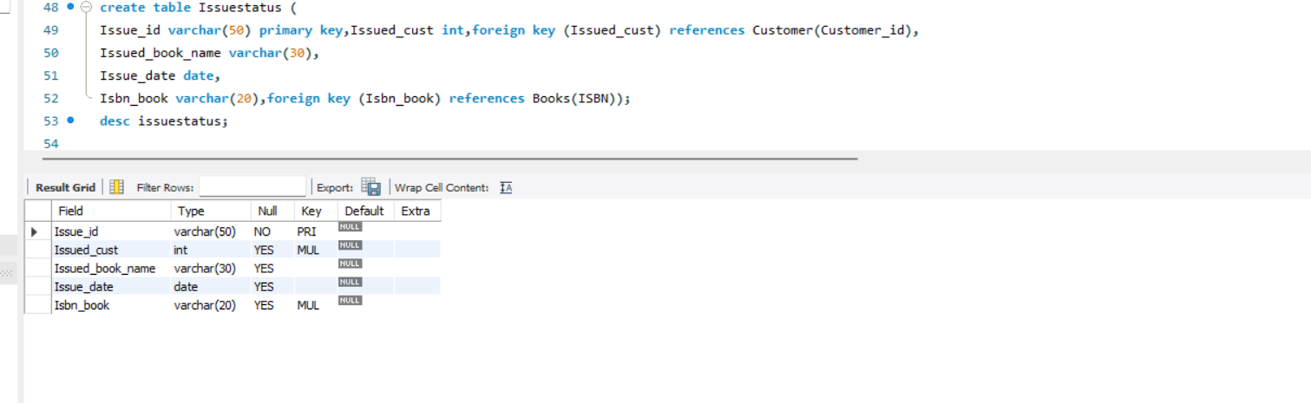

CREATE TABLE”Returnstatus”

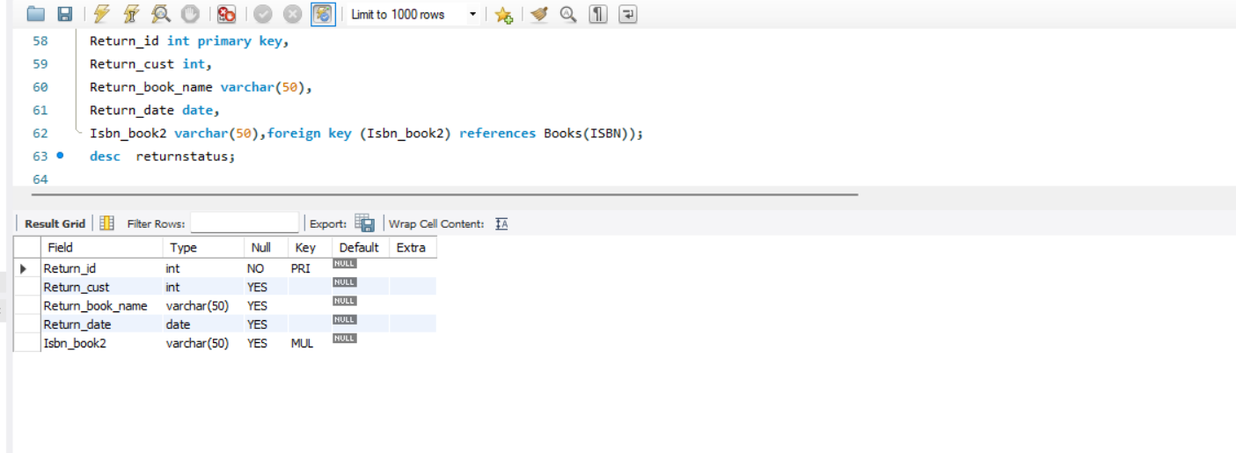

INSERT VALUES IN TABLE BRANCH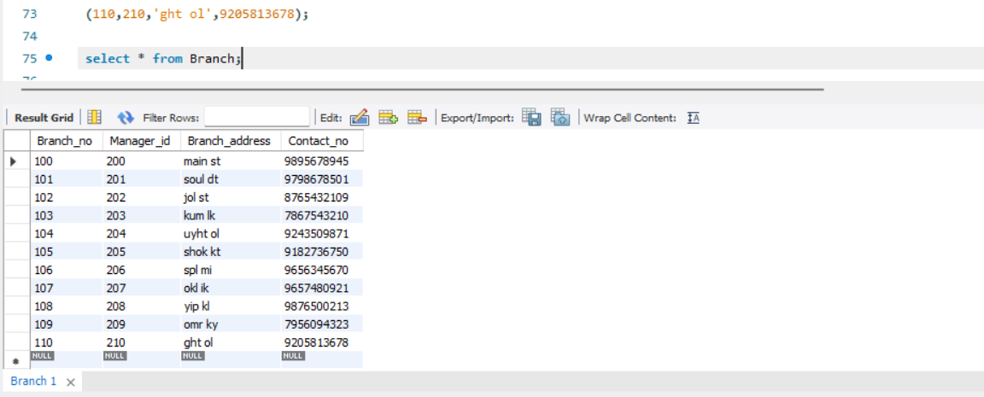

INSERT VALUES IN TABLE EMPLOYEE

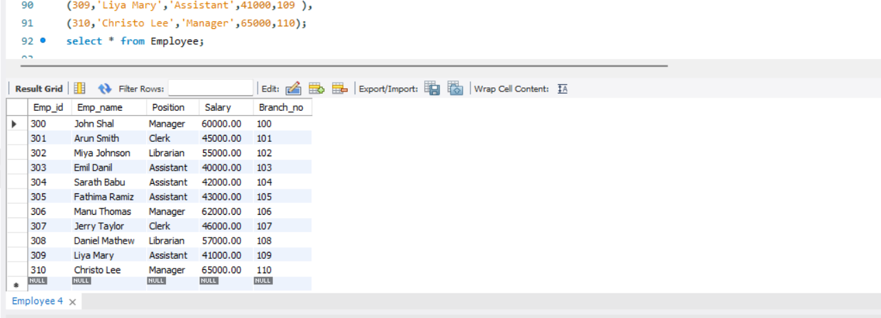

INSERT VALUES IN TABLE BOOKS

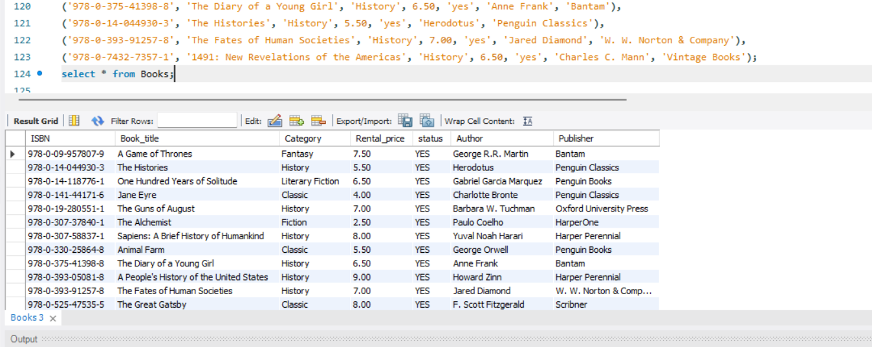

INSERT VALUE IN TABLE CUSTOMER

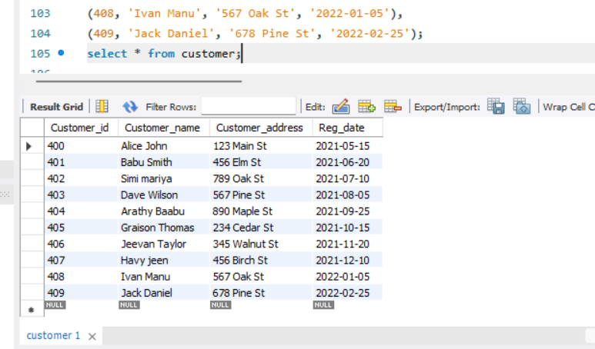

INSERT VALUE IN TABLE ISSUESTATUS

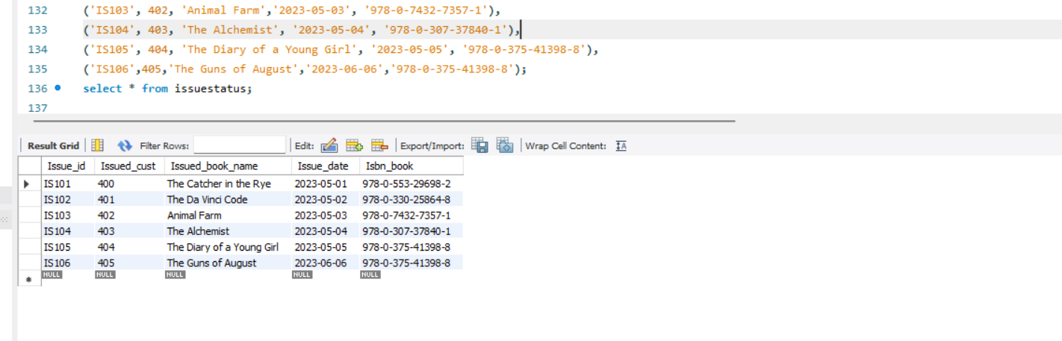

INSERT VALUE IN TABLE RETURNSTATUS

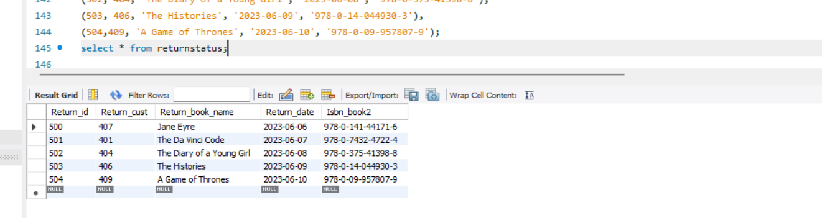

QUERIES

* QUESTION 1

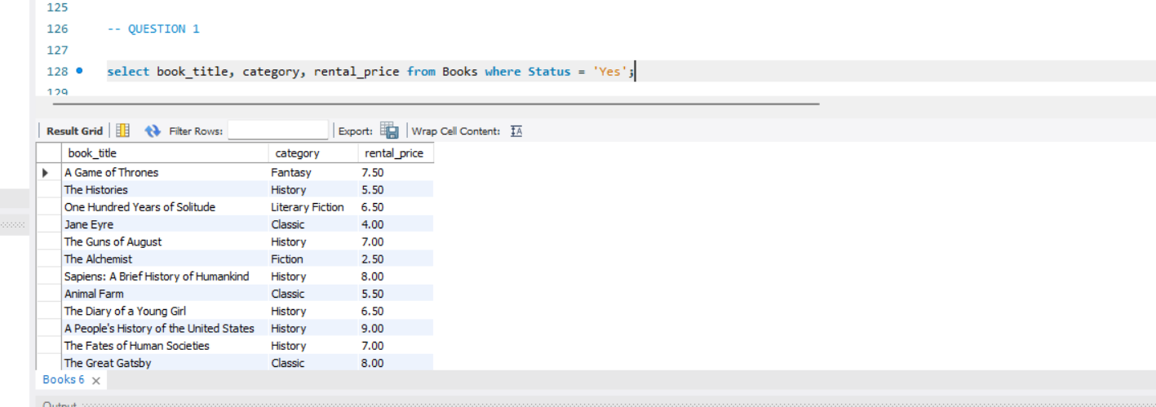

QUESTION 2

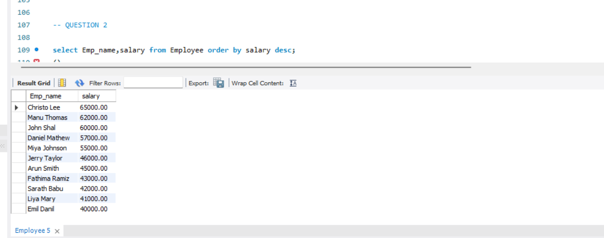

QUESTION 3

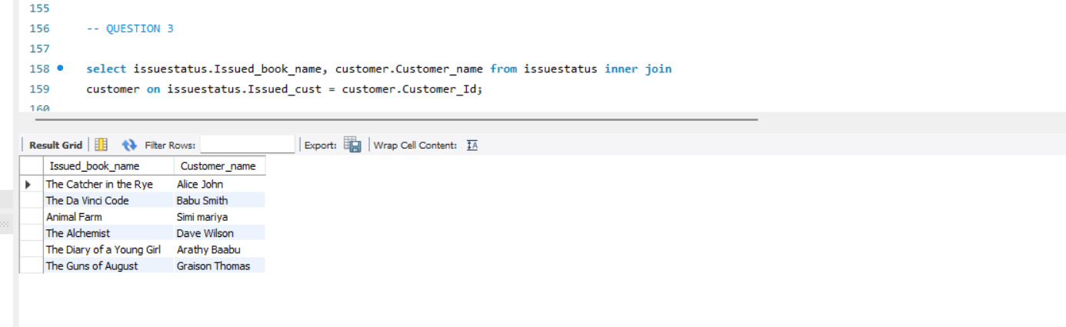

QUESTION 4

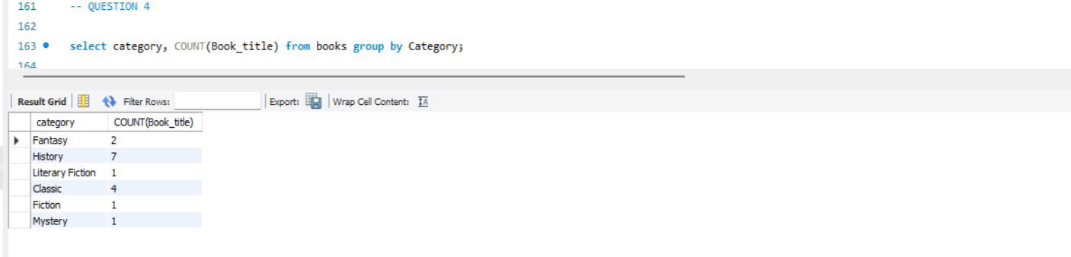

QUESTION 5

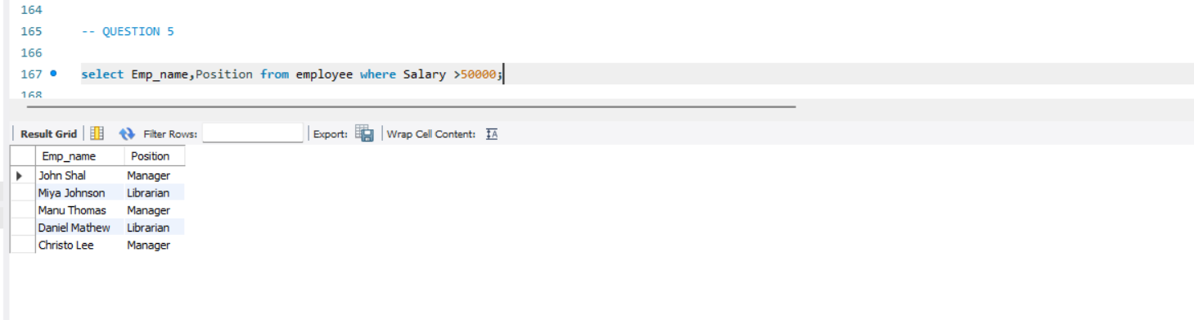

QUESTION 6

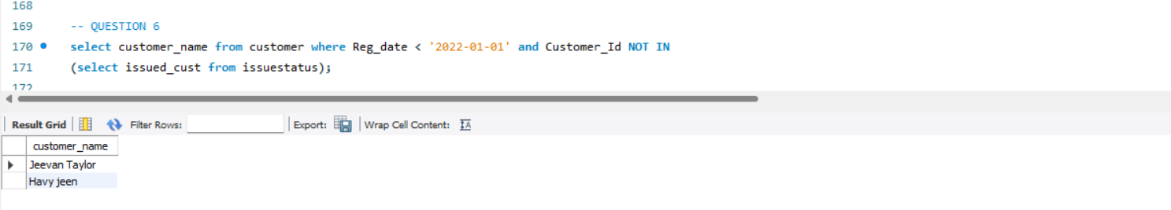

QUESTION 7

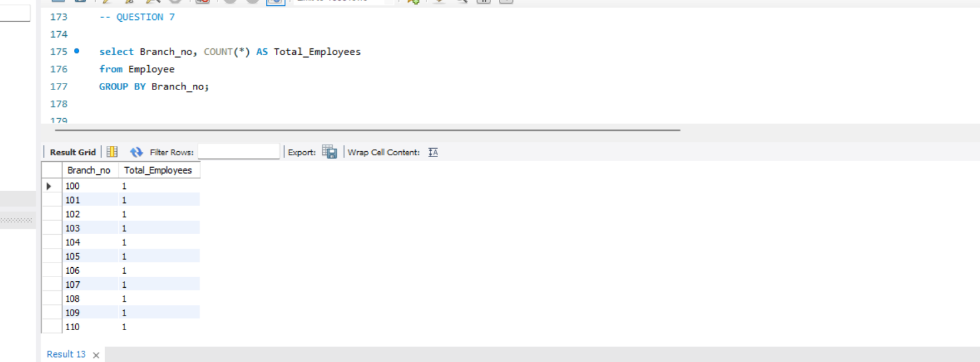

QUESTION 8

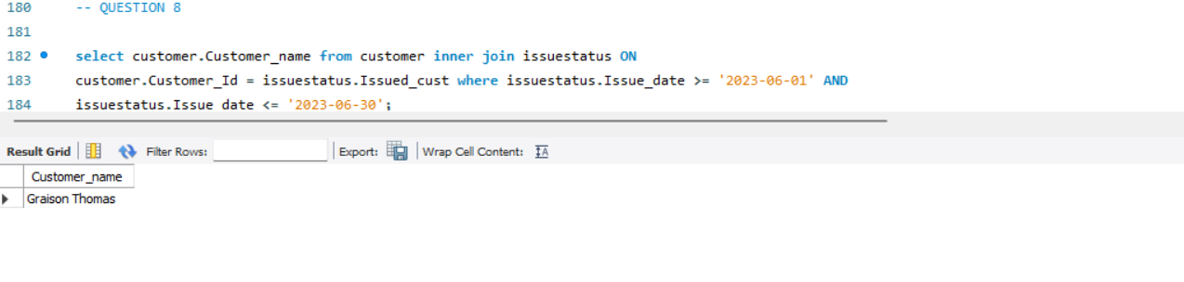QUESTION 9

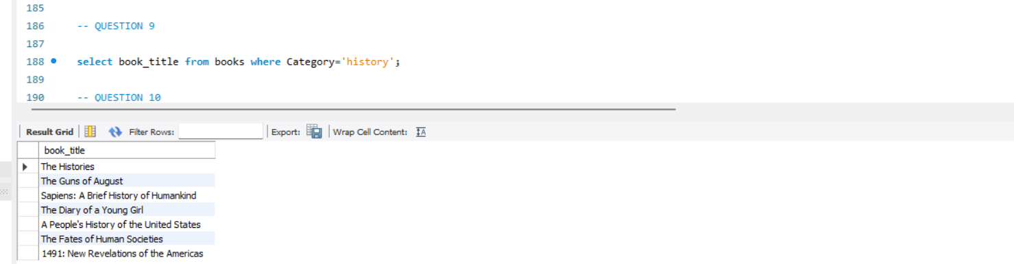

QUESTION 10

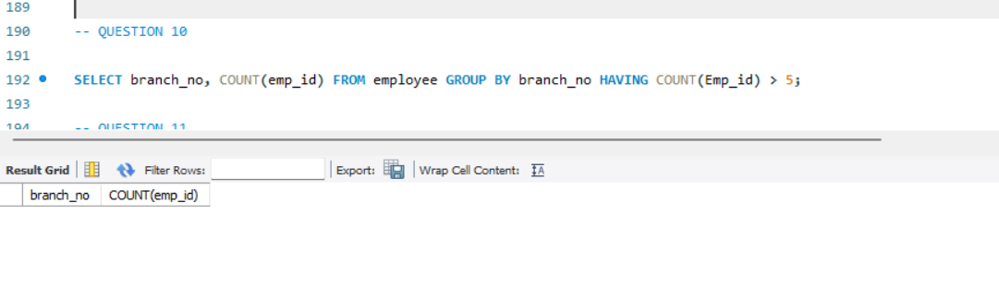

QUESTION11

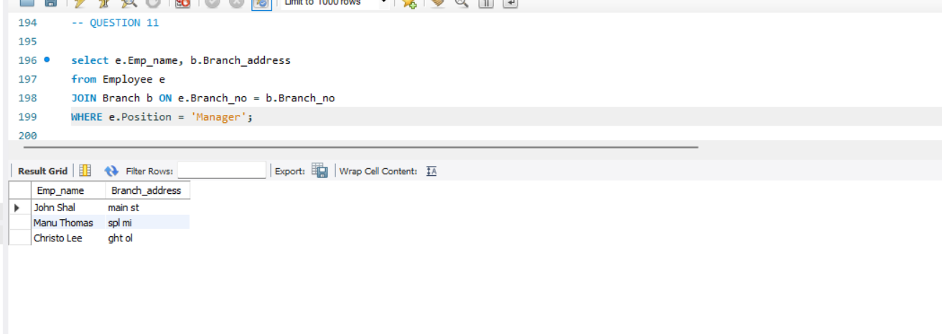QUESTION 12

